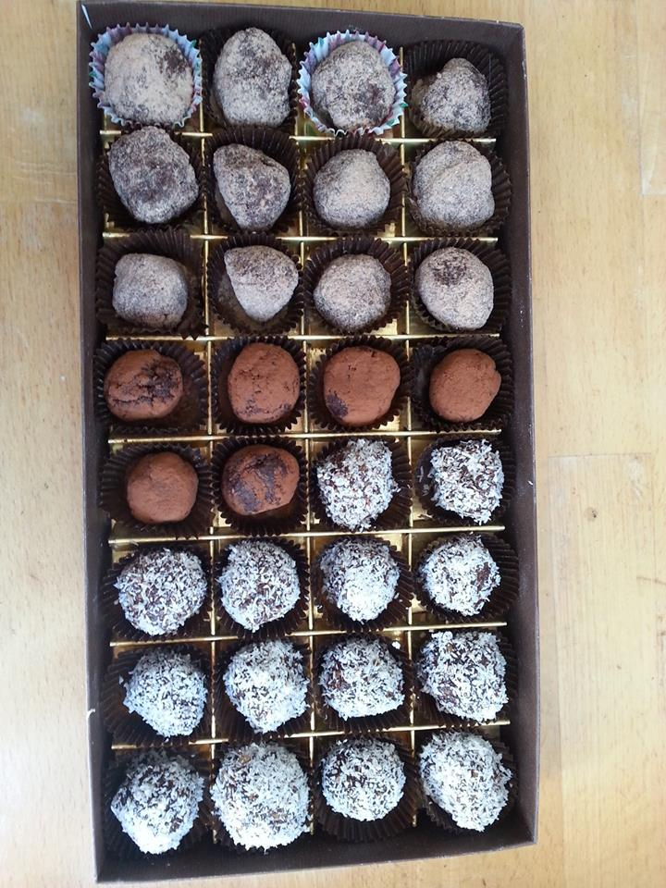
Fertility Truffles:
Here is a quick and easy recipe for you to make your own delicious truffles which support fertility and hormones. Buy the ingredients, such as ground macca root and whey protein from wholefood shops. Supermarkets sell ground flaxseeds (also known as linseeds) – some come with a variety of other ingredients as well such as gogi berries/raspberries/sesame seeds etc

100g ground linseeds mix (mine had goji berries/raspberries/sesame seeds in)
50grams ground nuts (choose ones to suit your palate – almonds, cashews, macadamia, walnuts, pecans, Brazils)
Approx half a tablespoon of ground macca root
Half a tablespoon of raw cocoa powder
Sprinkling of salt
1 teaspoon pure vanilla essence (optional) or add 3-8 drops of rose essential oil or lavender oil instead
2 teaspoons rose water
Enough honey (Manuka or regular) or raw coconut butter or Chywanaprash to make it all stick together (Each will offer a different flavour)

Add all the “dry” ingredients together. Start to add the honey/chywanaprash or coconut butter to the dry mixture. I tend to use about a dessertspoon of it to begin and mix. If it feels to dry then add more. The consistency needs to be similar to play-doh when you first get it out of the pot or pastry when it softens. I tend to make a variety of flavours so at this stage split into different dishes if you want more than one flavour. Add the “flavouring”, i.e. Essential oils, vanilla essence, rose water. When you feel happy with the taste and texture make into small mouthful sized balls. Roll each ball into your own choice of coating - I love desiccated coconut, ground macca powder, sesame seeds, ground flaxseeds, cocoa powder but you can use anything that takes your fancy! I have found that placing them into the mini muffin cases looks good and placing them in the fridge overnight appears to increase their flavour!

Another Form of Yummy Truffles:
1 cup (about 150 grams) ground almonds or other nut or you could use plain or flavoured whey or hemp protein powder or ground flaxseeds
¼ cup chocolate powder or cocoa (20g)
2.5 – 3 tablespoons agave syrup or honey but go sparingly on this as it's all about the consistency
½-1 teaspoon vanilla extract and pinch of salt (both optional)
anything you fancy to coat them with
Process the nuts to breadcrumb size in a food processor of coffee grinder, or buy them already ground!. Combine nuts, chocolate powder, agave and vanilla/salt. Mix and shape into balls.
I change the recipe dependant to what I have in my cupboard – I often coat the balls in desiccated coconut or macca, and add a few drops of essential oils – bergamot, lavender, rose etc or spices such as blackpepper, sea salt, chilli powder, turmeric, ginger!

